МИНИСТЕРСТВО НАУКИ И ВЫСШЕГО ОБРАЗОВАНИЯ РОССИЙСКОЙ ФЕДЕРАЦИИ

Федеральное государственное бюджетное образовательное учреждение высшего образования

«Казанский национальный исследовательский технический университет

им. А.Н. Туполева – КАИ»

Институт компьютерных технологий и защиты информации

Отделение СПО ИКТЗИ (Колледж информационных технологий)

ЛАБОРАТОРНАЯ РАБОТА №4

по дисциплине

РАЗРАБОТКА ПРОГРАММНЫХ МОДУЛЕЙ

Тема: «Пользовательские элементы в WPF приложениях, классы Path и Geometry»

Работу выполнил

Студент гр.4338

Бусов В.Р

Принял

Преподаватель

Лоповок Е.Е.

Казань 2024

**Цель работы**

Изучить использование пользовательских элементов в WPF-приложениях, научиться использованию классов Path и Geometry.

**Задание на лабораторную работу**

1. Разработать WPF-приложение «Дорожные знаки» с заданным интерфейсом. По запросу «Дорожные знаки Российской Федерации» найдите в Википедии соответствующую страницу и выберите на ней сложные три знака, отличных от изображенных в примере. Обязательно, чтобы при нажатии на знак открывался SVG файл. В первом столбце знаки изображаются с помощью объектов Path, во втором– с помощью картинок в формате PNG. Конвертацию SVG-файла в XAML- и PNG-файлы можно произвести с помощью программы Inkscape. При нажатии на любой знак он плавно увеличивается и перемещается в правую часть окна. Через две секунды он плавно возвращается в исходное со стояние. При наведении курсора мыши на какой-то один знак плавно меняется цвет какой-либо части этого знака.
2. Разработайте WPF-приложение «Карусель товаров»

**Результат выполнения работы**

1. В третьем задании я сравнил использование векторной графики и картинок. Для этого я с помощью программы Inkscape получил код XAML по векторному изображению. Результат работы представлен на рисунке 3.

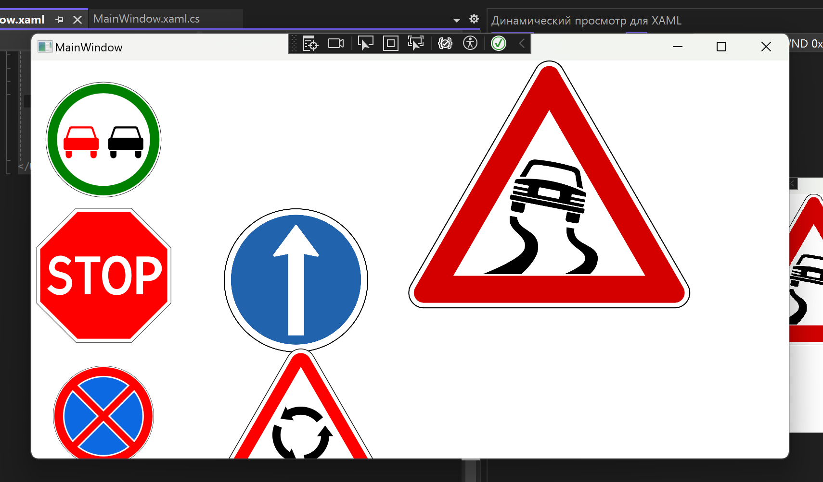

Рисунок 1 – Задание 1

1. Результат выполнения второго задания можно посмотреть на рисунке 2

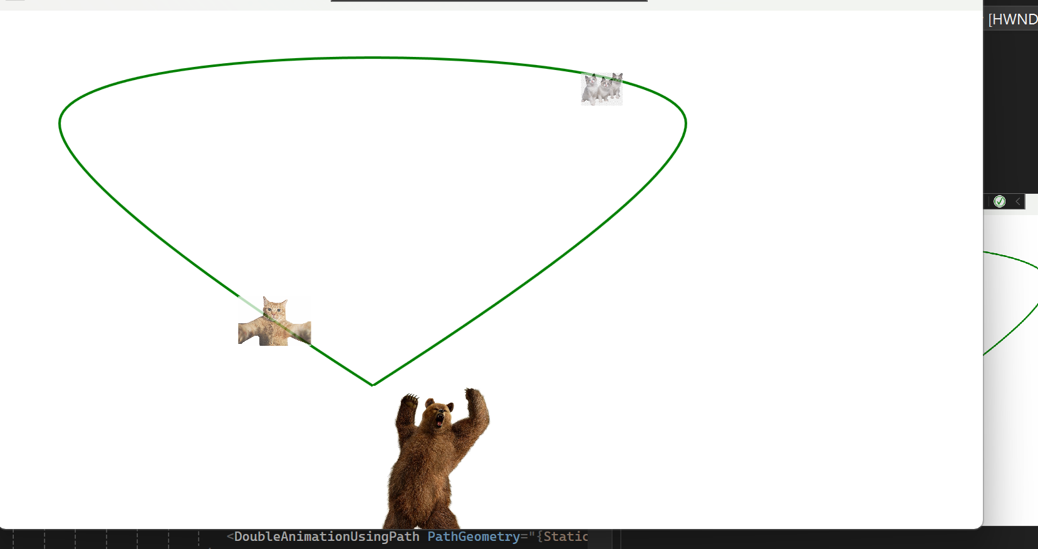

Рисунок 2 – Задание 2

**Листинг программы**

Задание 1. XAML

<Window x:Class="prm12l2.MainWindow"

xmlns="http://schemas.microsoft.com/winfx/2006/xaml/presentation"

xmlns:x="http://schemas.microsoft.com/winfx/2006/xaml"

xmlns:d="http://schemas.microsoft.com/expression/blend/2008"

xmlns:mc="http://schemas.openxmlformats.org/markup-compatibility/2006"

xmlns:local="clr-namespace:prm12l2"

mc:Ignorable="d"

Title="MainWindow" Height="450" Width="800">

<Window.Resources>

<Style TargetType="Path" x:Key="first">

<Style.Triggers>

<EventTrigger RoutedEvent="MouseEnter">

<BeginStoryboard>

<Storyboard>

<ColorAnimation Storyboard.TargetProperty="Fill.(SolidColorBrush.Color)" To="Green" Duration="0:0:1"/>

</Storyboard>

</BeginStoryboard>

</EventTrigger>

<EventTrigger RoutedEvent="MouseLeave">

<BeginStoryboard>

<Storyboard>

<ColorAnimation Storyboard.TargetProperty="Fill.(SolidColorBrush.Color)" Duration="0:0:1"/>

</Storyboard>

</BeginStoryboard>

</EventTrigger>

</Style.Triggers>

</Style>

<Style TargetType="Image" x:Key="f">

<Setter Property="RenderTransform">

<Setter.Value>

<TranslateTransform X="0" Y="0"/>

</Setter.Value>

</Setter>

<Style.Triggers>

<EventTrigger RoutedEvent="MouseDown">

<BeginStoryboard>

<Storyboard>

<DoubleAnimation Storyboard.TargetProperty="RenderTransform.X" To="200" Duration="0:0:5" AutoReverse="True"/>

<DoubleAnimation Storyboard.TargetProperty="Width" To="300" Duration="0:0:5" AutoReverse="True"/>

</Storyboard>

</BeginStoryboard>

</EventTrigger>

</Style.Triggers>

</Style>

<Style TargetType="Image" x:Key="s">

<Setter Property="RenderTransform">

<Setter.Value>

<TranslateTransform X="0" Y="0"/>

</Setter.Value>

</Setter>

<Style.Triggers>

<EventTrigger RoutedEvent="MouseDown">

<BeginStoryboard>

<Storyboard>

<DoubleAnimation Storyboard.TargetProperty="RenderTransform.X" To="200" Duration="0:0:5" AutoReverse="True"/>

<DoubleAnimation Storyboard.TargetProperty="RenderTransform.Y" To="-150" Duration="0:0:5" AutoReverse="True"/>

<DoubleAnimation Storyboard.TargetProperty="Width" To="300" Duration="0:0:5" AutoReverse="True"/>

</Storyboard>

</BeginStoryboard>

</EventTrigger>

</Style.Triggers>

</Style>

<Style TargetType="Image" x:Key="th">

<Setter Property="RenderTransform">

<Setter.Value>

<TranslateTransform X="0" Y="0"/>

</Setter.Value>

</Setter>

<Style.Triggers>

<EventTrigger RoutedEvent="MouseDown">

<BeginStoryboard>

<Storyboard>

<DoubleAnimation Storyboard.TargetProperty="RenderTransform.X" To="200" Duration="0:0:5" AutoReverse="True"/>

<DoubleAnimation Storyboard.TargetProperty="RenderTransform.Y" To="-300" Duration="0:0:5" AutoReverse="True"/>

<DoubleAnimation Storyboard.TargetProperty="Width" To="300" Duration="0:0:5" AutoReverse="True"/>

</Storyboard>

</BeginStoryboard>

</EventTrigger>

</Style.Triggers>

</Style>

</Window.Resources>

<Canvas>

<StackPanel Orientation="Vertical" Grid.Column="0">

<Canvas Name="layer1" Width="100" Height="100">

<Canvas.RenderTransform>

<TranslateTransform X="-250" Y="-670"/>

</Canvas.RenderTransform>

<Path xmlns:x="http://schemas.microsoft.com/winfx/2006/xaml" Name="path5334" Fill="#FFFFFFFF" StrokeThickness="2.35558" Opacity="1">

<Path.Data>

<PathGeometry Figures="m 360.11998 752.36227 a 60.119998 60.120002 0 0 1 -60.12 60.11999 60.119998 60.120002 0 0 1 -60.12 -60.11999 60.119998 60.120002 0 0 1 60.12 -60.11999 60.119998 60.120002 0 0 1 60.12 60.11999 z" FillRule="NonZero"/>

</Path.Data>

</Path>

<Path xmlns:x="http://schemas.microsoft.com/winfx/2006/xaml" Name="path3003" StrokeThickness="0.4008" Stroke="#FF000000" Opacity="1">

<Path.Data>

<PathGeometry Figures="m 359.91957 752.36229 a 59.9196 59.919602 0 0 1 -59.91959 59.91959 59.9196 59.919602 0 0 1 -59.91961 -59.91959 59.9196 59.919602 0 0 1 59.91961 -59.9196 59.9196 59.919602 0 0 1 59.91959 59.9196 z" FillRule="NonZero"/>

</Path.Data>

</Path>

<Path xmlns:x="http://schemas.microsoft.com/winfx/2006/xaml" Name="path47759" Fill="#FFFF0000" StrokeThickness="0.2004" Opacity="1" Style="{StaticResource first}">

<Path.Data>

<PathGeometry Figures="m 299.99998 694.24626 c -32.09658 0 -58.116 26.01942 -58.116 58.116 0 32.09658 26.01942 58.116 58.116 58.116 32.09658 0 58.116 -26.01942 58.116 -58.116 0 -32.09658 -26.01942 -58.116 -58.116 -58.116 z m 0 9.82586 c 26.6698 0 48.29014 21.62034 48.29014 48.29014 0 26.6698 -21.62034 48.29014 -48.29014 48.29014 -26.66979 0 -48.29014 -21.62034 -48.29014 -48.29014 0 -26.6698 21.62035 -48.29014 48.29014 -48.29014 z" FillRule="NonZero"/>

</Path.Data>

</Path>

<Path xmlns:x="http://schemas.microsoft.com/winfx/2006/xaml" Name="path13111" Fill="#FFFF0000" StrokeThickness="0.710018" Opacity="1">

<Path.Data>

<PathGeometry Figures="m 266.30899 738.61017 c -0.83171 0 -1.71942 0.63459 -1.99055 1.42087 l -1.00533 2.91545 -2.08437 6.03866 c -0.002 0.006 -0.002 0.0112 -0.003 0.0168 l -0.48592 1.40411 c -1.18816 0 -2.1447 0.95654 -2.1447 2.1447 v 8.57879 c 0 1.18817 0.95654 2.1447 2.1447 2.1447 h 32.17048 c 1.18816 0 2.1447 -0.95653 2.1447 -2.1447 v -8.57879 c 0 -1.18816 -0.95654 -2.1447 -2.1447 -2.1447 l -0.48592 -1.40411 c -0.002 -0.006 -10e-4 -0.0112 -0.003 -0.0168 l -2.08438 -6.03866 -1.00533 -2.91545 c -0.27116 -0.78628 -1.15883 -1.42087 -1.99054 -1.42087 H 276.8254 266.30968 Z m 0.65347 2.1447 h 9.86225 9.86226 c 0.41584 0 0.85971 0.31729 0.99528 0.71043 l 3.083 8.94072 h -13.94054 -13.94053 l 3.083 -8.94072 c 0.13556 -0.39314 0.57944 -0.71043 0.99528 -0.71043 z" FillRule="NonZero"/>

</Path.Data>

</Path>

<Path xmlns:x="http://schemas.microsoft.com/winfx/2006/xaml" Name="path13113" Fill="#FFFF0000" StrokeThickness="0.2004" Opacity="1">

<Path.Data>

<PathGeometry Figures="m 260.73894 764.34633 v 4.2894 c 0 1.77672 1.44033 3.21704 3.21705 3.21704 1.77672 0 3.21705 -1.44032 3.21705 -3.21704 v -4.2894 z" FillRule="NonZero"/>

</Path.Data>

</Path>

<Path xmlns:x="http://schemas.microsoft.com/winfx/2006/xaml" Name="path13117" Fill="#FFFF0000" StrokeThickness="0.2004" Opacity="1">

<Path.Data>

<PathGeometry Figures="m 286.47532 764.34633 v 4.2894 c 0 1.77672 1.44033 3.21704 3.21705 3.21704 1.77672 0 3.21705 -1.44032 3.21705 -3.21704 v -4.2894 z" FillRule="NonZero"/>

</Path.Data>

</Path>

<Path xmlns:x="http://schemas.microsoft.com/winfx/2006/xaml" Name="path13130" Fill="#FF000000" StrokeThickness="0.710018" Opacity="1">

<Path.Data>

<PathGeometry Figures="m 312.65957 738.61017 c -0.83171 0 -1.71941 0.63459 -1.99054 1.42087 l -1.00533 2.91545 -2.08438 6.03866 c -0.002 0.006 -0.002 0.0112 -0.003 0.0168 l -0.48592 1.40411 c -1.18816 0 -2.14469 0.95654 -2.14469 2.1447 v 8.57879 c 0 1.18817 0.95653 2.1447 2.14469 2.1447 h 32.17048 c 1.18816 0 2.1447 -0.95653 2.1447 -2.1447 v -8.57879 c 0 -1.18816 -0.95654 -2.1447 -2.1447 -2.1447 l -0.48592 -1.40411 c -0.002 -0.006 -0.001 -0.0112 -0.003 -0.0168 l -2.08439 -6.03866 -1.00533 -2.91545 c -0.27116 -0.78628 -1.15883 -1.42087 -1.99054 -1.42087 h -10.51573 -10.51572 z m 0.65347 2.1447 h 9.86226 9.86225 c 0.41584 0 0.85972 0.31729 0.99528 0.71043 l 3.083 8.94072 H 323.1753 309.23476 l 3.083 -8.94072 c 0.13557 -0.39314 0.57944 -0.71043 0.99528 -0.71043 z" FillRule="NonZero"/>

</Path.Data>

</Path>

<Path xmlns:x="http://schemas.microsoft.com/winfx/2006/xaml" Name="path13132" Fill="#FF000000" StrokeThickness="0.2004" Opacity="1">

<Path.Data>

<PathGeometry Figures="m 307.08952 764.34633 v 4.2894 c 0 1.77672 1.44033 3.21704 3.21705 3.21704 1.77672 0 3.21705 -1.44032 3.21705 -3.21704 v -4.2894 z" FillRule="NonZero"/>

</Path.Data>

</Path>

<Path xmlns:x="http://schemas.microsoft.com/winfx/2006/xaml" Name="path13134" Fill="#FF000000" StrokeThickness="0.2004" Opacity="1">

<Path.Data>

<PathGeometry Figures="m 332.8259 764.34633 v 4.2894 c 0 1.77672 1.44033 3.21704 3.21705 3.21704 1.77672 0 3.21705 -1.44032 3.21705 -3.21704 v -4.2894 z" FillRule="NonZero"/>

</Path.Data>

</Path>

</Canvas>

<Canvas Name="svg20" Width="150" Height="150" Margin="0 50 0 0">

<Canvas.RenderTransform>

<TranslateTransform X="0" Y="0"/>

</Canvas.RenderTransform>

<Path xmlns:x="http://schemas.microsoft.com/winfx/2006/xaml" Name="path14" Fill="#FFFFFFFF" StrokeThickness="0.2" Opacity="1">

<Path.Data>

<PathGeometry Figures="M 46.288059 3.7735953 5.2830193 44.778645 v 57.989885 l 41.0050397 41.00506 h 57.989881 l 41.00508 -41.00503 V 44.778655 L 104.27798 3.7735953 Z" FillRule="NonZero"/>

</Path.Data>

</Path>

<Path xmlns:x="http://schemas.microsoft.com/winfx/2006/xaml" Name="path16" StrokeThickness="0.4" Stroke="#FF000000" StrokeMiterLimit="4" StrokeLineJoin="Miter" StrokeStartLineCap="Flat" StrokeEndLineCap="Flat" Opacity="1">

<Path.Data>

<PathGeometry Figures="M 5.4830193 102.68575 V 44.861545 L 46.370879 3.9735953 h 57.824251 l 40.88789 40.8878997 v 57.824215 l -40.88787 40.88788 H 46.370949 Z" FillRule="NonZero"/>

</Path.Data>

</Path>

<Path xmlns:x="http://schemas.microsoft.com/winfx/2006/xaml" Name="path18" Fill="#FFFF0000" StrokeThickness="0.2" Style="{StaticResource first}">

<Path.Data>

<PathGeometry Figures="M 47.945519 7.7735954 9.2830193 46.436095 v 54.674995 l 38.6624997 38.6625 h 54.675001 l 38.6625 -38.6625 V 46.436095 L 102.62052 7.7735954 Z M 30.476769 53.148595 c 3.01568 0.22514 5.61619 1.12433 7.8 2.7 2.18376 1.57574 3.32723 2.47493 3.43125 2.7 l -3.74375 4.9125 c -3e-5 -0.16368 -0.6209 -0.82275 -1.86875 -1.96875 -1.2479 -1.14594 -3.12302 -1.79876 -5.61875 -1.9625 -2.44378 0.12281 -4.1036 0.86193 -4.9875 2.2125 -0.88393 1.35063 -1.30201 2.57624 -1.25 3.68125 0.078 1.65904 0.96015 2.84816 2.65 3.56875 1.68982 0.72064 3.72171 1.33616 6.0875 1.8375 2.94635 0.74694 5.26397 2.07416 6.9625 3.9875 1.69847 1.91337 2.56531 4.34926 2.6 7.30625 -0.0174 2.66029 -1.12391 5.32097 -3.325 7.98125 -2.20114 2.66028 -5.39185 4.08911 -9.56875 4.29375 -2.51851 -0.0849 -4.75928 -0.67773 -6.71875 -1.78125 -1.95949 -1.10352 -3.49744 -2.20898 -4.625 -3.3125 -1.12757 -1.10352 -1.70851 -1.69636 -1.73125 -1.78125 l 4.1 -4 c 0.01 0.1871 0.78106 0.94033 2.30625 2.25 1.52517 1.30968 3.74712 2.05666 6.66875 2.24375 2.64305 -0.13301 4.42898 -0.85055 5.35625 -2.15 0.92722 -1.29944 1.36064 -2.38654 1.3 -3.25625 0.0627 -0.51147 0.0343 -1.1521 -0.0813 -1.93125 -0.11557 -0.77913 -0.69727 -1.57246 -1.74375 -2.375 -1.04652 -0.80251 -2.93238 -1.49334 -5.6625 -2.075 -4.61889 -1.09479 -7.5483 -2.71152 -8.7875 -4.85 -1.23922 -2.13844 -1.77716 -4.12473 -1.6125 -5.95625 0.0606 -3.51973 1.18879 -6.42678 3.38125 -8.71875 2.19244 -2.2919 5.08492 -3.47436 8.68125 -3.55625 z m 58.35625 0 c 5.17293 0.14913 9.02442 2.16485 11.556251 6.05 2.53177 3.88521 3.78963 8.74287 3.78125 14.575 0.008 5.83217 -1.24948 10.68983 -3.78125 14.575 -2.531831 3.88518 -6.383321 5.9009 -11.556251 6.05 -5.17297 -0.1491 -9.02446 -2.16482 -11.55625 -6.05 -2.53181 -3.88517 -3.79592 -8.74283 -3.7875 -14.575 -0.008 -5.83213 1.25569 -10.68979 3.7875 -14.575 2.53179 -3.88515 6.38328 -5.90087 11.55625 -6.05 z m -43.31875 0.98125 h 26.175 v 5.89375 h -9.93125 v 33.39375 h -6.3125 v -33.39375 h -9.93125 z m 63.637501 0 h 13.2625 c 4.84987 0.22514 8.28656 1.74026 10.3125 4.54375 2.02588 2.80356 3.01136 5.54428 2.95 8.225 -0.0614 2.68077 -1.29328 5.42149 -3.6875 8.225 -2.39428 2.80354 -5.5846 4.31866 -9.575 4.54375 h -6.3875 v 13.75 h -6.875 z m -20.318751 5.4 c -2.63976 0.041 -4.77996 1.30971 -6.41875 3.80625 -1.63881 2.4966 -2.48219 5.97643 -2.53125 10.4375 0.049 4.4611 0.89244 7.94094 2.53125 10.4375 1.63879 2.49658 3.77898 3.76533 6.41875 3.80625 2.63973 -0.0409 4.77992 -1.30967 6.41875 -3.80625 1.63877 -2.49656 2.48215 -5.9764 2.53125 -10.4375 -0.0491 -4.46107 -0.89247 -7.9409 -2.53125 -10.4375 -1.63883 -2.49654 -3.77903 -3.76529 -6.41875 -3.80625 z m 27.193751 0.49375 v 13.75 h 4.425 c 2.04635 0.0205 3.84474 -0.50916 5.4 -1.59375 1.55522 -1.08456 2.37437 -2.84605 2.45625 -5.28125 -0.0819 -2.43515 -0.90103 -4.19665 -2.45625 -5.28125 -1.55526 -1.08455 -3.35365 -1.61418 -5.4 -1.59375 z" FillRule="NonZero"/>

</Path.Data>

</Path>

</Canvas>

<Canvas x:Name="svg40" Width="130" Height="130">

<Canvas.RenderTransform>

<TranslateTransform X="0" Y="0"/>

</Canvas.RenderTransform>

<Ellipse xmlns:x="http://schemas.microsoft.com/winfx/2006/xaml" Canvas.Left="12.4" Canvas.Top="17.9" Width="105" Height="105" x:Name="circle26" Fill="#FFFFFFFF" StrokeThickness="0.15"/>

<Ellipse xmlns:x="http://schemas.microsoft.com/winfx/2006/xaml" Canvas.Left="12.6" Canvas.Top="18" Width="104.7" Height="104.7" x:Name="circle28" StrokeThickness="0.3" Stroke="#FF000000"/>

<Path xmlns:x="http://schemas.microsoft.com/winfx/2006/xaml" x:Name="path30" Fill="#FFFF0000" StrokeThickness="0.15" Style="{StaticResource first}">

<Path.Data>

<PathGeometry Figures="m 64.948454 121.36082 c 28.16655 0 50.999996 -22.833445 50.999996 -50.999995 0 -28.16655 -22.833446 -51 -50.999996 -51 -28.16655 0 -51 22.83345 -51 51 0 28.16655 22.83345 50.999995 51 50.999995 z m 27.216 -19.011 c -7.5957 6.46245 -17.2431 10.011 -27.216 10.011 -9.9729 0 -19.6203 -3.5487 -27.216 -10.011 l 27.216 -27.215995 z m -59.205 -4.772995 c -6.46245 -7.5957 -10.011 -17.2431 -10.011 -27.216 0 -9.9729 3.5487 -19.6203 10.011 -27.216 l 27.216 27.216 z m 4.773 -59.205 c 7.5957 -6.46245 17.2431 -10.011 27.216 -10.011 9.9729 0 19.6203 3.5487 27.216 10.011 l -27.216 27.216 z m 59.205 4.773 c 6.462446 7.5957 10.010996 17.2431 10.010996 27.216 0 9.9729 -3.5487 19.6203 -10.010996 27.216 l -27.216 -27.216 z" FillRule="NonZero"/>

</Path.Data>

</Path>

<Path xmlns:x="http://schemas.microsoft.com/winfx/2006/xaml" x:Name="path32" Fill="#FF0D69E1" StrokeThickness="0.15">

<Path.Data>

<PathGeometry Figures="m 33.071654 45.378325 c -5.58705 7.1289 -8.6232 15.92505 -8.6232 24.9825 0 9.05745 3.03615 17.85345 8.6232 24.9825 l 24.9825 -24.9825 z" FillRule="NonZero"/>

</Path.Data>

</Path>

<Path xmlns:x="http://schemas.microsoft.com/winfx/2006/xaml" x:Name="path34" Fill="#FF0D69E1" StrokeThickness="0.15">

<Path.Data>

<PathGeometry Figures="m 39.965954 102.23762 c 7.1289 5.58705 15.92505 8.6232 24.9825 8.6232 9.05745 0 17.85345 -3.03615 24.9825 -8.6232 l -24.9825 -24.982495 z" FillRule="NonZero"/>

</Path.Data>

</Path>

<Path xmlns:x="http://schemas.microsoft.com/winfx/2006/xaml" x:Name="path36" Fill="#FF0D69E1" StrokeThickness="0.15">

<Path.Data>

<PathGeometry Figures="m 96.825254 95.343325 c 5.587046 -7.1289 8.623196 -15.92505 8.623196 -24.9825 0 -9.05745 -3.03615 -17.85345 -8.623196 -24.9825 l -24.9825 24.9825 z" FillRule="NonZero"/>

</Path.Data>

</Path>

<Path xmlns:x="http://schemas.microsoft.com/winfx/2006/xaml" x:Name="path38" Fill="#FF0D69E1" StrokeThickness="0.15">

<Path.Data>

<PathGeometry Figures="m 89.930954 38.484025 c -7.1289 -5.58705 -15.92505 -8.6232 -24.9825 -8.6232 -9.05745 0 -17.85345 3.03615 -24.9825 8.6232 l 24.9825 24.9825 z" FillRule="NonZero"/>

</Path.Data>

</Path>

</Canvas>

</StackPanel>

<Image Source="C:\Users\Амир\Desktop\college\рпм\car.png" Width="130" Canvas.Left="200" Canvas.Top="0" Style="{StaticResource f}"/>

<Image Source="C:\Users\Амир\Desktop\college\рпм\strel.png" Margin="0 4 0 0" Width="150" Canvas.Left="200" Canvas.Top="150" Style="{StaticResource s}"/>

<Image Source="C:\Users\Амир\Desktop\college\рпм\raz.png" Width="160" Canvas.Left="200" Canvas.Top="300" Style="{StaticResource th}"/>

</Canvas>

</Window>

Задание 2 XAML

<Window x:Class="rpm12lab1.MainWindow"

xmlns="http://schemas.microsoft.com/winfx/2006/xaml/presentation"

xmlns:x="http://schemas.microsoft.com/winfx/2006/xaml"

xmlns:d="http://schemas.microsoft.com/expression/blend/2008"

xmlns:mc="http://schemas.openxmlformats.org/markup-compatibility/2006"

xmlns:local="clr-namespace:rpm12lab1"

mc:Ignorable="d"

Title="MainWindow" Height="450" Width="800">

<Window.Resources>

<PathGeometry x:Key="path1" >

<PathFigure StartPoint="300,300">

<QuadraticBezierSegment Point1="50, 140" Point2="50, 90"></QuadraticBezierSegment>

<BezierSegment Point1="50,20" Point2="550,20" Point3="550,90"></BezierSegment>

<QuadraticBezierSegment Point1="550, 140" Point2="300, 300"></QuadraticBezierSegment>

</PathFigure>

</PathGeometry>

<Style TargetType="Image">

<Setter Property="Opacity" Value="1"></Setter>

<Setter Property="Width" Value="100"></Setter>

<Setter Property="Stretch" Value="Fill"></Setter>

<Setter Property="Canvas.Top" Value="10"></Setter>

<Setter Property="Canvas.Left" Value="10"></Setter>

<Style.Triggers>

<EventTrigger RoutedEvent="MouseDown">

<BeginStoryboard>

<Storyboard>

<DoubleAnimationUsingPath PathGeometry="{StaticResource path1}" Storyboard.TargetProperty="(Canvas.Top)" Duration="0:0:5" Source="Y" RepeatBehavior="Forever"></DoubleAnimationUsingPath>

<DoubleAnimationUsingPath PathGeometry="{StaticResource path1}" Storyboard.TargetProperty="(Canvas.Left)" Duration="0:0:5" Source="X" RepeatBehavior="Forever"></DoubleAnimationUsingPath>

</Storyboard>

</BeginStoryboard>

</EventTrigger>

<MultiTrigger>

<MultiTrigger.Conditions>

<Condition Property="Canvas.Left" Value="300"></Condition>

<Condition Property="Canvas.Top" Value="300"></Condition>

</MultiTrigger.Conditions>

<MultiTrigger.EnterActions>

<BeginStoryboard>

<Storyboard>

<DoubleAnimation Storyboard.TargetProperty="Width" Duration="0:0:2.5" To="20" RepeatBehavior="Forever" AutoReverse="True"></DoubleAnimation>

<DoubleAnimation Storyboard.TargetProperty="Opacity" Duration="0:0:2.5" To="0.5" RepeatBehavior="Forever" AutoReverse="True"></DoubleAnimation>

</Storyboard>

</BeginStoryboard>

</MultiTrigger.EnterActions>

</MultiTrigger>

</Style.Triggers>

</Style>

</Window.Resources>

<Canvas>

<Path Stroke="Green" StrokeThickness="2" Data="{StaticResource path1}"></Path>

<Image Source="C:\Users\Амир\Desktop\college\рпм\cats.jpg" ></Image>

<Image Source="C:\Users\Амир\Desktop\college\рпм\catt.jpg" ></Image>

<Image Source="C:\Users\Амир\Desktop\college\рпм\bears.jpg" ></Image>

</Canvas>

</Window>